Changes in VB website

* Nav bar mai contact us pura ek line mai ana chahiye
* Venus brassoctech thoda bada ho sakta ho toh it is better
* Mission vision ka text mai kuch kuch highlight karna tha wo pele wale doc mai bheja hai
* Mission vision ke photos ki dimension

-MISSION To be changed to-

To **raise the benchmark of quality**, **service** and **design with every project**, while **valuing customer satisfaction.**

-Vision mai highlight karni hai

To be the company of choice for **Global markets**, driven by **entrepreneurial spirit** and **execution excellence.**

**Yeh rahe highlight karne wale points**

* About page ke landing page mai abhi abhi purana picture hai change it to same as the home page
* Product page ke landing ka photo upload karta hun
* Footer mai logo bada nahi ho sakta ?
* Logo left mai chahiye nav bar mai
* Pre-loader

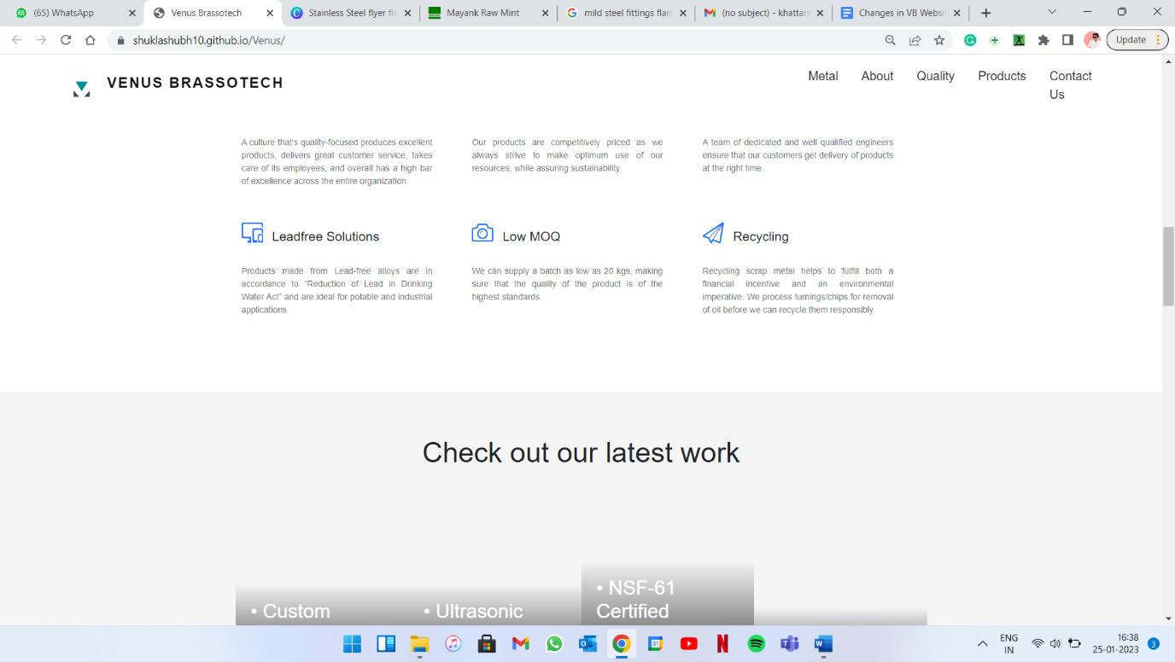

**LOGO and VENUS BRASSOTECH aligned nahi hai**

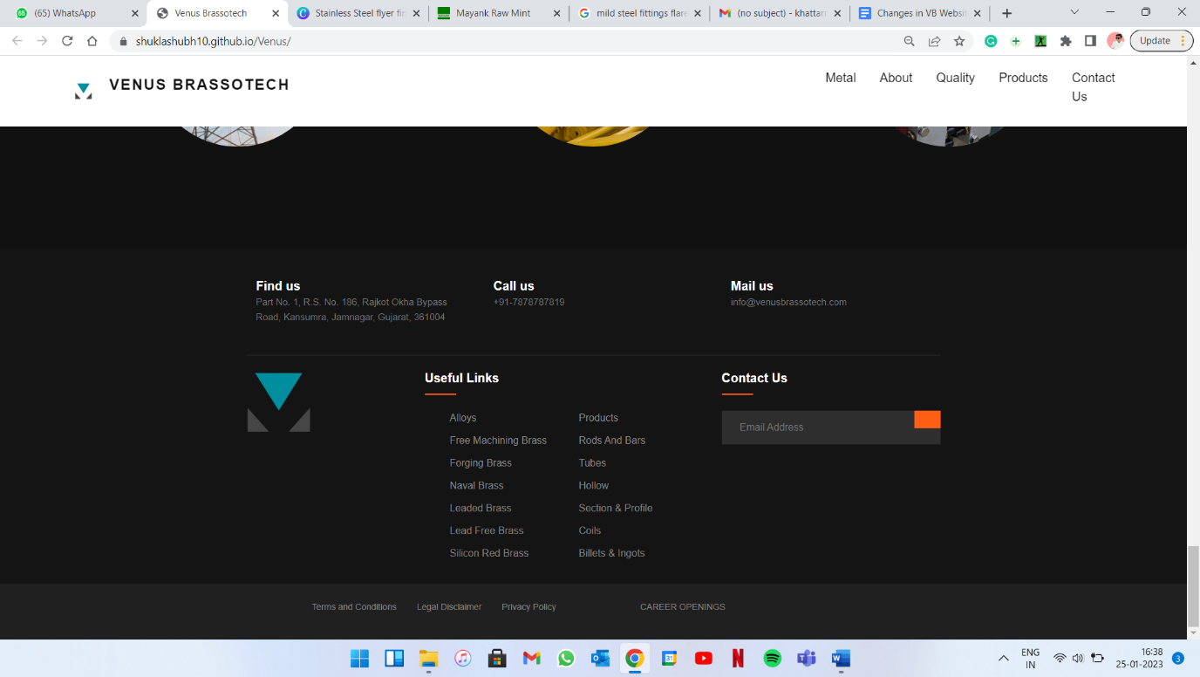

**Niche wali line ko align karo na**

**Terms and condition walo ko thoda left aur career openings ko right**

**Career opening agar caps hata sakte ho toh thike warna its fine**

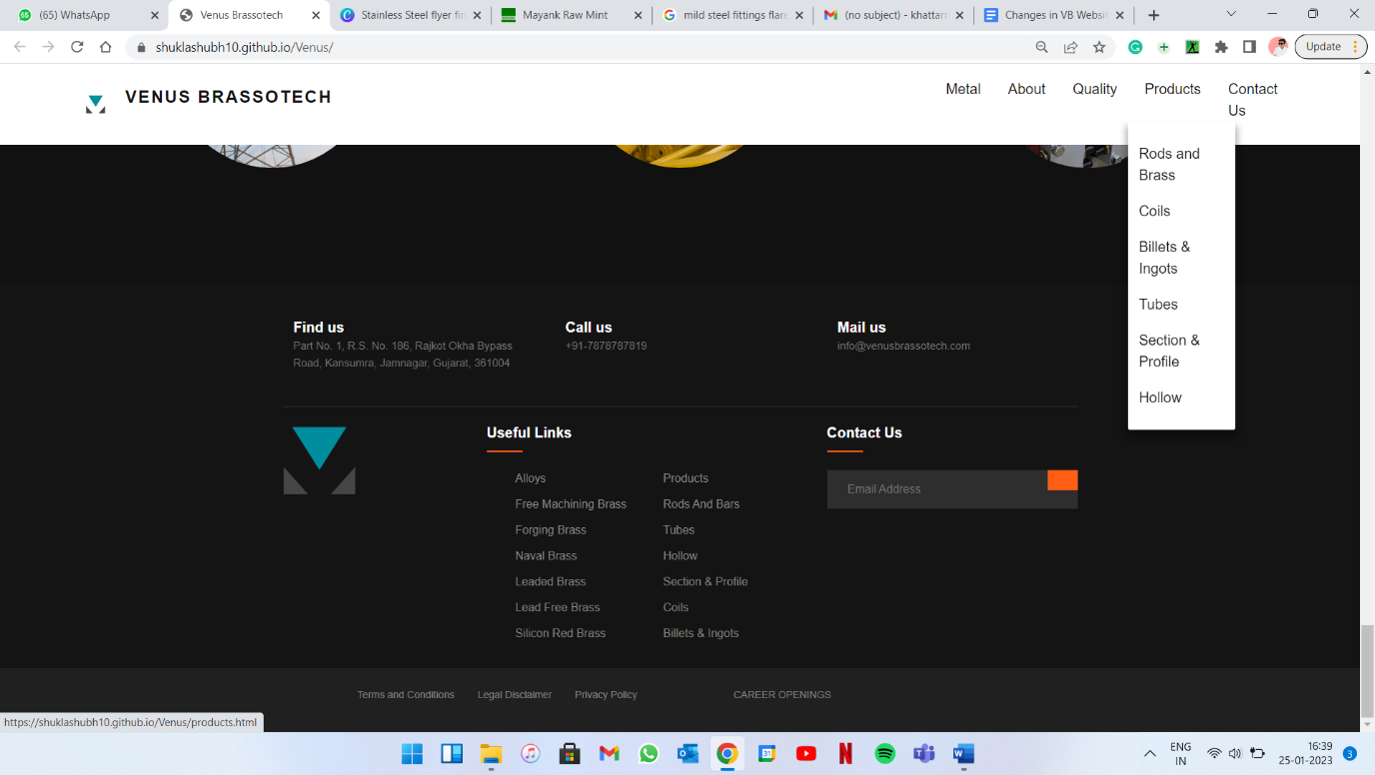

**Products-1**

**Its RODS & BARS**